Press release

182,000 jobs for rural Indian women
On 11 December, Women on Wings unveiled its latest milestone of 182,000 jobs at the ACCESS Livelihoods Asia Summit 2014 in New Delhi. Ronald van het Hof, Managing Director of Women on Wings India: “The growth in the number of jobs is the result of great mutual understanding and a strong motivation by our Indian business partners to create sustainable jobs for women.”

Women on Wings’ Session at Livelihoods Asia Summit 2014
In 12 Plenary Sessions, over 600 delegates from around 8 countries in the Asia region, explored scalable solutions that offer a pathway out of poverty. The session of Women on Wings looked at the obstacles that people in rural India face, in their efforts to improve their positions within markets and identified ways to strengthen the poorly functioning markets. Ronald van het Hof led the panel discussions with experts in the field of creating social impact through sustainable business models: Dilip Barooah, Founder and CEO at Fabric Plus, Ashwini Sahay, Deputy General Manager Marketing at Jharcraft, Siva Devireddy, Founder and MD at GoCoop and Yogesh Kumar Ghore, Senior Program Staff at Coady International Institute, Canada.

Growth comes in many shapes for sustainable development
For the future Women on Wings expects to see an increase in the number of jobs especially in agro and food sector. Van het Hof: “More and more Indian organizations are interested in working with us, also from the agro and food sector. We started collaborating with social enterprises in peeled tomatoes and fresh dips. And there is a growing interest in social investment and sustainable business practices. The Modi government certainly creates a change with its many programs for growth and rural development.”

545,000 children in school
A job and an income provide women in rural India with greater self-sufficiency, purchasing power and a better social position. These 182,000 jobs mean two meals a day and better livelihoods for 182,000 Indian families. It also means over 545,000 children can go to (a better) school thanks to the fact their mothers have a job with an income.

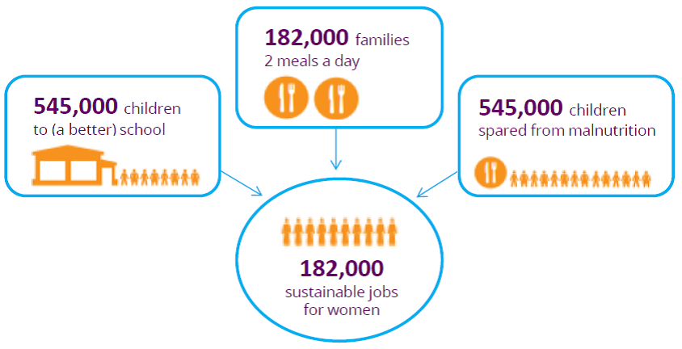

Women on Wings’ mission: 1 million jobs
Women on Wings’ mission is to create 1 million jobs for women in rural India in ten years. It provides business consultancy to Indian social entrepreneurs who in their turn create sustainable jobs for women in rural India. A team of 60 experts, from India and The Netherlands, share their time and business knowledge pro bono. The experts and the social entrepreneur will, jointly, focus on finding suitable and realistic business models to enable the company to grow faster and develop more sustainable job opportunities. Fabric Plus and Jharcraft, two of the participants in the Making Markets Work for the Poor Session, are two of the social enterprises Women on Wings collaborates with.

__________________________________________________________________________
Information for the editors, not for publication:
For more information, please contact Women on Wings India
T: +91 98 18346771 or E: info@womenonwings.com, http://www.womenonwings.com

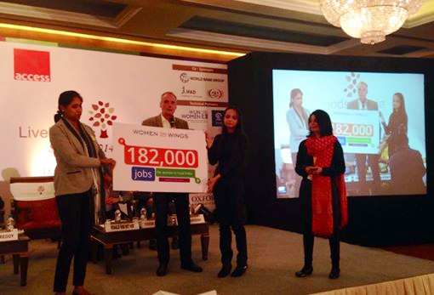

The number of jobs unveiled at the ACCESS Livelihoods Asia summit 2014 by Women on Wings India staff

