Press release

The aim is to create 1 million jobs for women in rural India

Women on Wings sounds the stock exchange bell after creating 51,300 jobs for women in India

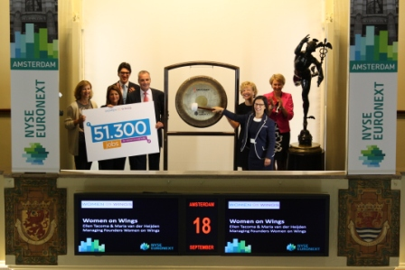
Women on Wings, the Dutch organisation that works to improve the economic position of Indian women, is celebrating the fact that in just five years they have created 51,300 jobs for women in rural India. On the morning of Tuesday, September 18, 2012 at 9 am, the two founders of Women on Wings, Maria van der Heijden and Ellen Tacoma, rang the Euronext stock exchange bell to celebrate the result.

Women on Wings was founded in 2007 by Maria Van der Heijden and Ellen Tacoma, two women with years of experience in the Dutch business world. Their mission is to create 1 million jobs for women in rural India. Having a job improves the position of women and improves the chance of a better life for women and for their children. “During our five year anniversary celebration on September 17, HRH Princess Máxima announced the result of 51,300 jobs. This milestone shows that the focus on jobs and income for women works. With an annual doubling of the number of women, we will realise over 1 million jobs for Indian women after ten years,” say Van der Heijden and Tacoma.

The aim of Women on Wings is to pass on focused knowledge of management, finance, organisation and marketing to Indian organisations. Dutch and Indian experts provide their knowledge and skills and are temporarily linked to a company in India. Together with local parties, they look for suitable and realistic business models. There are currently fifty Women on Wings experts working with fifty Indian organisations. Women on Wings works without subsidies; the input of experts is given on a voluntary basis. This is one of the reasons why international companies and organisations such as AkzoNobel, DHL, IKEA Foundation, Hyva Group and Cordaid are delighted to help meet the aims of Women on Wings.

Austerlitz, September 18, 2012

Note for the editor, not for publication:
For more information or an interview with the founders of Women on Wings, please contact Ingrid Looijmans, press officer for Women on Wings,
T: 06-54680742, E: press@womenonwings.nl, http://www.womenonwings.nl

