Press release

100,000 jobs for Indian women

Austerlitz, 17 December 2013 – The Dutch organization Women on Wings has created 100,000 jobs for women in rural India. Founders Ellen Tacoma and Maria van der Heijden: “This fantastic milestone means everything is going according to plan. With our figures doubling each year, we expect to reach our ambitious objective of creating more than 1 million jobs for women within ten years. This growth will be realized with the voluntary help of sixty experienced managers and entrepreneurs from Dutch and Indian companies.” These experts will advise twenty rural Indian companies and will jointly develop suitable and realistic business models to help them expand their businesses and create more jobs for women.

260,000 children in school
Of the 1.2 billion people in India, 700 to 800 million living in the countryside are forced to live on less than 2 dollars a day. Women on Wings strengthens the economic position of women by creating jobs. A job and an income provides women in rural India with greater self-sufficiency and purchasing power and a better social position. These 100,000 extra jobs means two meals a day and a better existence for 100,000 families. It also means more money is spent on education for children: 100,000 jobs means 260,000 children in school.

Make a difference in just one generation
Research shows that women in rural India spend their income on their family. Durga and Anjali are excellent examples. Durga is 31 years old and lives and works in Delwara, a village in Rajasthan. She is also a group leader at Sadhna, a co-op in Udaipur that employs 700 women in the production of handmade shawls, saris and pillows. Durga was forced into an arranged marriage when she was just 6 years old. She moved in with her husband and his family at age 15. One year later her daughter Anjali, now 16 herself, was born. Anjali is in high school now and is older than her mother was when she had her first child. Anjali wants to become a doctor or an accountant when she finishes high school and will only consider marriage when she can financially support herself. A lot has changed in just one generation. Durga works, has her own income and can send her daughter to school.

Investing in human capital
Women on Wings works with more than sixty experienced managers and entrepreneurs from the Dutch and Indian business community. These experts will work with local partners to strengthen economic activity. Their contribution ranges from creating new distribution channels to strengthening the local organization. The experts invest time and knowledge in exchange for the experience of a lifetime. Jan Anne Schelling is one of these experts. “The most stimulating part is the fantastic energy of the women we work with. They are eager to learn, resourceful and willing to implement the advice they find useful and they keep me grounded. My challenge is to really listen to what they need. I may have the expertise, experience and professionalism, but they know what’s useful or not.”

Women on Wings has a team of six experts and twenty Indian companies. Visit www.womenonwings.nl for more information.

__________________________________________________________________________
Information for the editors, not for publication:
For more information, please contact Women on Wings press officer Ingrid Looijmans on
T: 06-54680742 or E: press@womenonwings.nl, http://www.womenonwings.com

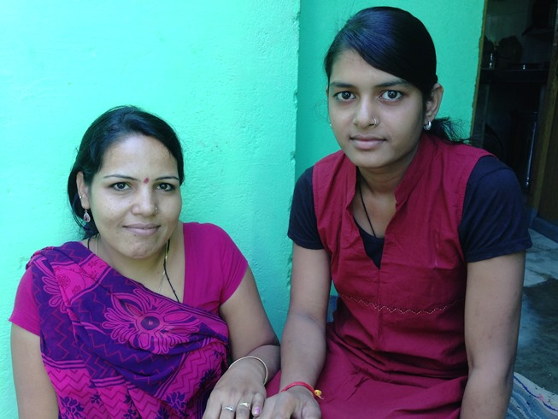
Mother Durga (31) and daughter Anjali (16) from Delwara, Rajasthan, India reveal how much can change in just one generation.

